Dear Applicant --

Thank you for your interest in working at Locust Grove Village! We appreciate you taking the time to see if there is a mutual interest in becoming a part of our Team.

It is very important that you understand the expectation of the job for which you are applying. We want you to have the opportunity to meet our Team and be given the time to ask questions about our facility.

We have implemented an interviewing process that allows us to select the best applicants for our positions.

- Complete the application and return it to: You can also print the application off of our website www.locustgrovevillage.com.
- If you meet the minimum requirements of the open position, you will be scheduled for a pre­ screen interview. The pre-screen will focus on the technical skills for the position. You will have an in depth behavior-based interview. Specific information about the department will be given to you at this time.
- Following the pre-screen, you will be scheduled for an interview with the department supervisor and a resident from Locust Grove Village. You will also be given an opportunity to tour our Home.
- The final step of the interview process will be shadowing in the department. You will be as­ signed a coach and spend two hours shadowing the position for which you are applying.

Once the applicant has completed all the steps of the interviewing process, the most qualified applicant will be given a conditional offer of employment. A letter will be sent to the remaining applicants who did not receive an offer for employment. Your application will remain active for 60-days. You can update your application at any time.

Important Information

It is important that our facility is a safe and drug-free workplace. The safety of our residents is our first priority. Therefore, as condition of employment at Locust Grove Village, we require a pre-employment drug screen.

We look forward to meeting with you. If you have any questions or concerns, please let me know how I can be of assistance.

Sincerely,

Charlotte Rathke
Administrator
Locust Grove Village

APPLICATION FOR EMPLOYMENT

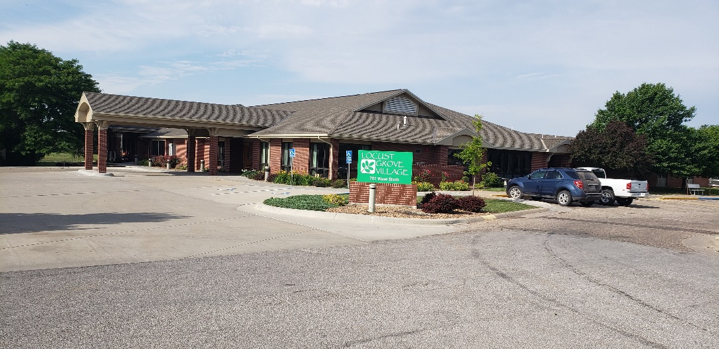

NAME:

701 W 6th Street
La Crosse, KS 67548
(785) 222-2574

APPLICATION FOR EMPLOYMENT

All information will be treated confidentially. Your application will remain under active consideration for sixty (60) days from the date it is filed. It will then become inactive unless you notify this facility that you want to remain under consideration

The use of this application form does not indicate that there is are any positions open and does not in any way obligate you or this facility

JOB INTEREST

Position Applied For: __________________
Date of Application: _________________
Full Time or PT: ______________________

Date Available for Work: ________________

Which Shifts Are You Available To Work?

Please print legibly or type
___Days _____Eve_____Nights
PERSONAL: I was referred to Locust Grove Village by:

Print Name:____________________________________________________________________________
(last) (first) (middle)

Address:_____________________________________________________________________________________
(street) (city) (state) (zip)

Telephone No: (______) _____________________________

Are you at least 16 years of age? ________Yes _________No

EDUCATION:

Name(s) of Educational Institutions |  | Location | Curriculum/ Major | Highest Grade Degree Completed
High School
College OR University
Trade or Vocational
Business OR Other

SPECIALIZED TRAINING:

List all licenses, areas of certification, or any other special training:

Have you ever been convicted of a felony? _______Yes ________No
(A record of a conviction may not disqualify you from consideration for employment.)

Have you ever been convicted in a court of law of a crime involving abuse, neglect, or mistreatment of an individual? _______Yes _______No
(This question is made pursuant to the provisions of CFR 483.13 (I) (ii)

PAST EMPLOYMENT :
Please indicate a continued record of employment, beginning with your most recent positions.
Include what you have done for the last 5 years, or from the time you left school

Employer’s Name | From Mo/Yr | To Mo/Yr | Address and Phone Number | Job Title and/ or Duties | Reason for Leaving
#1
Supervisor: | Rate of Pay:
#2
Supervisor: | Rate of Pay:
#3
Supervisor: | Rate of Pay:
#4
Supervisor: | Rate of Pay:
#5
Supervisor: | Rate of Pay:

If you are currently employed, may we contact your present employer? _______Yes _______No

REFERENCES:

Please list the names of three person,. not related to you and whom you have known at least one year.

NAME ADDRESS PHONE
11111

Q
1._____________________________________________________________________________________________

2._____________________________________________________________________________________________

3._____________________________________________________________________________________________

PLEASE READ THIS SECTION BEFORE SIGNING!
FALSIFICATION OF RECORDS
I certify that the information this application correct to the best of my knowledge. and understand that fal1sfication of this application or omission of requested information in any detail is grounds for disqualification from further cons1derat1on or for dismissal from employment.

EMPLOYMENT AT WILL
I agree to conform to the rules and regulations of the facility as communicated to me. I understand that in no event shall my hiring be considered as creating a contractual relationship between myself and this facility; and unless otherwise provided in writing, such relationship shall be defined as “employment at will” where either party may dissolve the relationship. I further understand that no employee or supervisor except the Chief Executive Officer (CEO) or designee has the authority to enter into any agreement or contract of employment for any specific terms of employment such as length of service, future salary increases, or agreement contrary to this application. Furthermore, I understand and agree that any such agreement entered into by the CEO or designee will not be enforceable unless it is in writing.

CONDITIONAL OFFER OF EMPLOYMENT
If I receive a conditional offer of employment, I understand that I may be subject of drugs screening, criminal background study, physical screening and evaluation, and I hereby consent to such screening and record checks.

PROOF OF RIGHT TO WORK
If I am offered a position with the facility, I understand that as a condition of employment I will be required to prove identify and right to work as required by the Immigration Reform and Control Act of 1986

RELEASE OF INFORMATION
I acknowledge that consideration for employment is contingent on the results of a reference and background check. Therefore, I hereby authorize the facility to (1) investigate the truthfulness of all statements made on this application; (2) contact my former employers and other listed references, of any other persons who can verify information; (3) discuss the results of any investigation with other employees of the facility involved in the firing process. In addition, I give my consent for all contacted persons including former employers to provide information concerning this application, and I release each such person from liability for providing information to the facility.
Applicant Signature | Date

Locust Grove Village is an equal opportunity employee and providers services to qualified individuals without regard to
race, color, sex, age, national origin, religion, or disability

If you need assistance to complete this application or during the interview process such as sign language interpreters, readers, or other accommodations, please contact the Administrator’s office at this facility or utilize the TDD or hearing impaired relay system.

TO BE COMPLETED AT THE TIME OF THE INTERVIEW

I Acknowledge I have read and understand the essential job duties for the position for which I have applied
Signature______________________________________ Date___________________

